
Lab - Search for BIOS or UEFI Firmware Updates
Introduction
In this lab, you will identify the current BIOS or UEFI version, and then search for BIOS or UEFI update files.

Recommended Equipment
• Classroom computer with an operating system installed • Internet access

Instructions
Step 1: Boot your computer.
During POST, BIOS information is displayed on the screen for a short period of time.
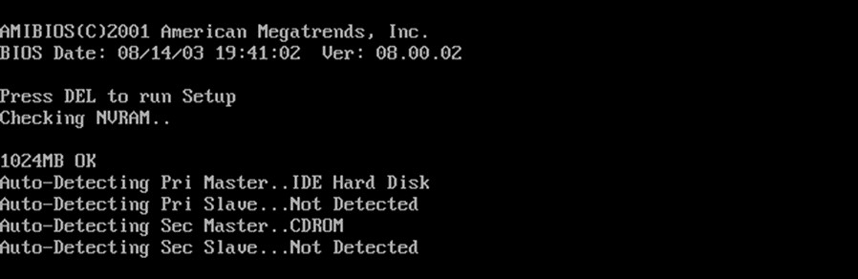
Do not log on to Windows.
Question:
What key or combination of keys is used to run Setup on your computer?
FN + F4.
Step 2: Restart your computer and enter Setup.
The BIOS Setup Utility or UEFI screen appears.
Questions:
Who is the manufacturer of the BIOS?
Lenovo.
Which BIOS version is installed in your computer?
G5CN67WW (V2. 13).

 2015 - 2019 Cisco and/or its affiliates. All rights reserved. Cisco Public | Page 1 of 2 | www.netacad.com
Lab - Search for BIOS or UEFI Firmware Updates

Step 3: Search the Internet to find the most current version of BIOS for the motherboard.

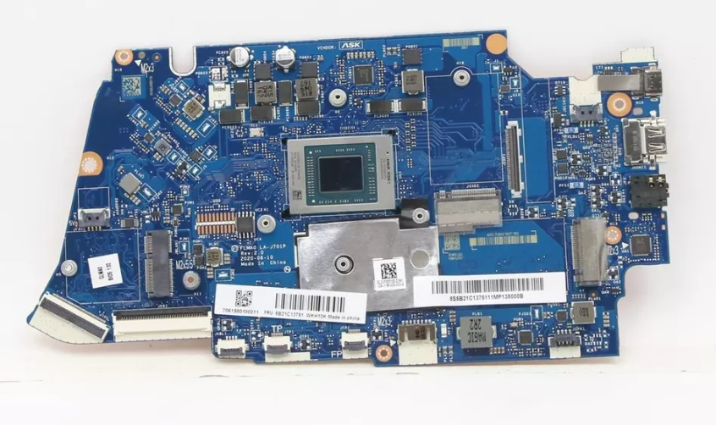
Caution: Do not update your BIOS at this time.
Questions:
What is the current BIOS version available for the motherboard?
G5CN70WW.
What features, if any, have been added to the new BIOS version?
Fixed all merged issues from previous model.
What changes, if any, have been made to the new BIOS version to fix problems?
1. Enhancement to address Security vulnerability CVE-2023-20593.
2. Enhancement to address Security vulnerabilities CVE-2023-20576,CVE-2023-20577,CVE-2023-20579,CVE-2023-20587.
What are the instructions to update the new BIOS version?
Do not power off or restart your computer during the BIOS flashing process, which will cause serious damage and improper functioning of your computer. End of Document
 2015 - 2019 Cisco and/or its affiliates. All rights reserved. Cisco Public Page 2 of 2 | www.netacad.com

Use the information from the previous step to search the Internet to find the most current version of the BIOS for the motherboard in your computer. The following screen is an example of the type of information you would look for to answer the questions below.


